

معهد القاهره العالي للهندسه وعلوم الحاسب والاداره

Cairo Higher Institute for Engineering,
Computer Science and Management

Project (1)
Security Company Management System

Supervisor: Eng.Hadeer

Team name:
- Omar Mohamed mokhtar
- 2017030018

Cairo 2020

Abstract

Design and construction of a
Security Company Management System :
A customer comes to the company and the supervisor speaks to him about the advantages of the company in security and give him a catalogue.
Then the customer chooses what he wants to secure
After that supervisor takes information (the id, name and address of the place to sign the contract). The supervisor gives the employees the address to secure it. The supervisor makes an update to the employees' file and make inventory to the customers file and makes reports to the manager.
The manager gives salary.

Acknowledgment

I would like to express my special thanks of gratitude to my teacher Eng.Hadeer Ashraf and Eng. Abdelrahman Sami as well as our principal Dr.Osama Fathy who gave me the golden opportunity to do this wonderful project on the topic System Analysis and Design, which also helped me in doing a lot of Research and i came to know about so many new things I am really thankful to them.
Secondly i would also like to thank my parents and friends who helped me a lot in finalizing this project within the limited time frame.

List of Figures

Figure 1.1 Functional Diagram (page 5)
Figure 1.2 Data flow Diagram (page 5)
Figure 1.3 Context Diagram (page 6)
Figure 2.1 Activity diagram (page 6 )
Figure 2.2 Class diagram (page 7)
Figure 2.3 Sequence diagram (page 8 )
Figure 2.4 State diagram (page 8 )
Figure 2.5 Use case diagram (page 9 )
Figure 3.1 Login Form (page 11 )
Figure 3.2 Manager view (page 11)
Figure 3.3 insert supervisor (page 12 )
Figure 3.4 Update supervisor (page 12)
Figure 3.5 Insert Employees (page 13)
Figure 3.6 Update employees (page 13 )
Figure 3.7 Supervisor view and send reports (page 14 )

Figures :
1.1
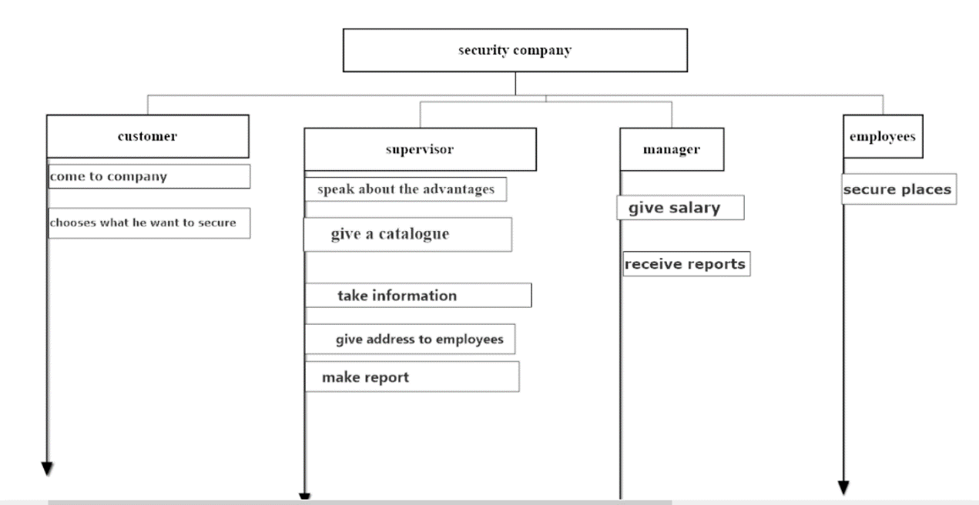
1.2
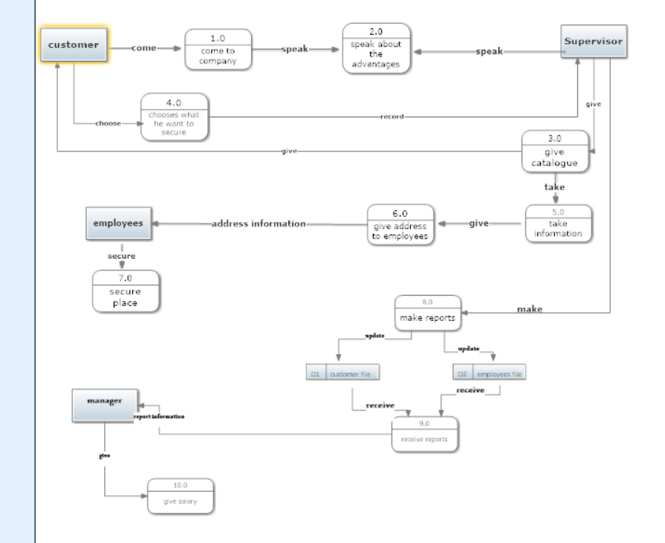

1.3
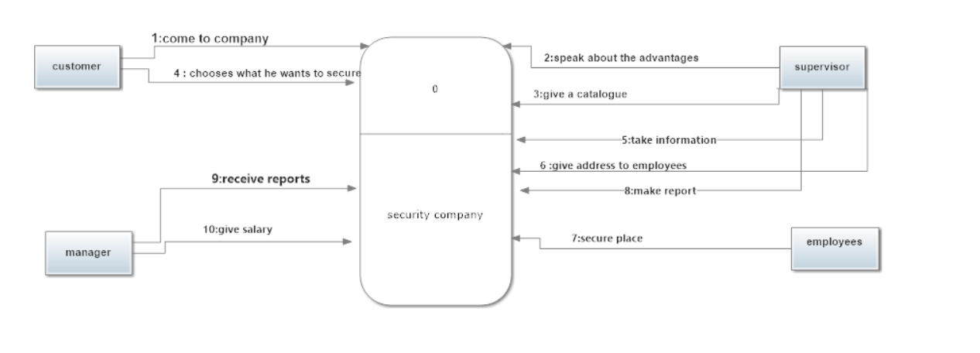
2.1
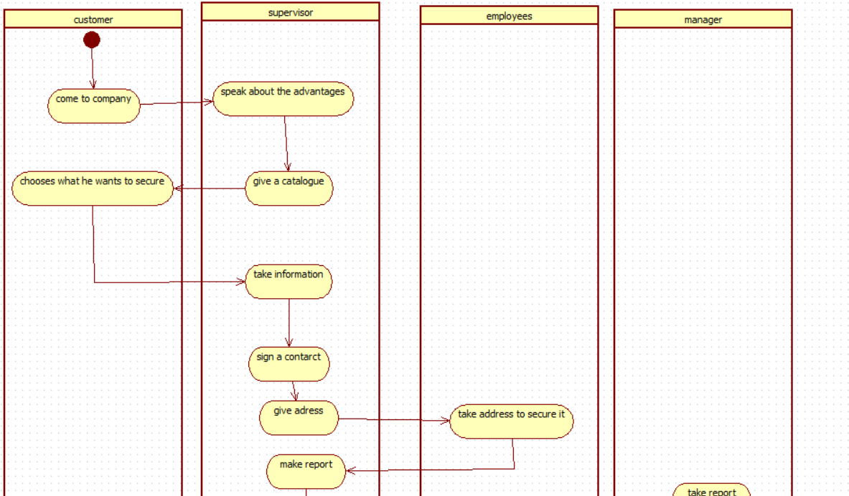

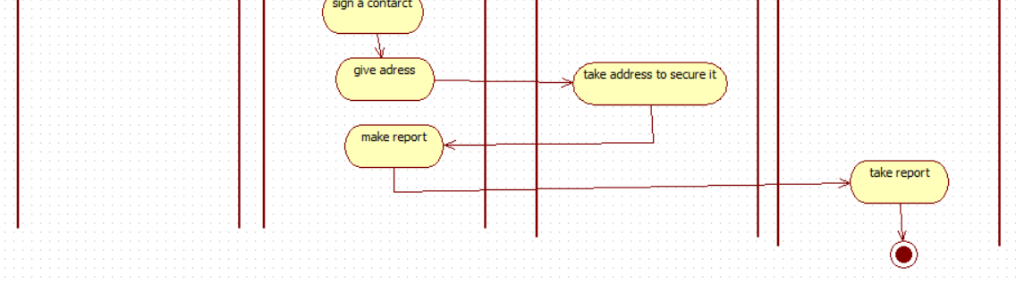

2.2

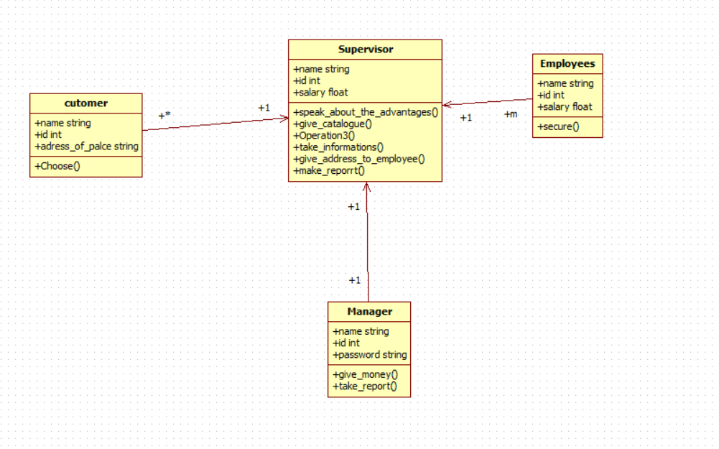

2.3

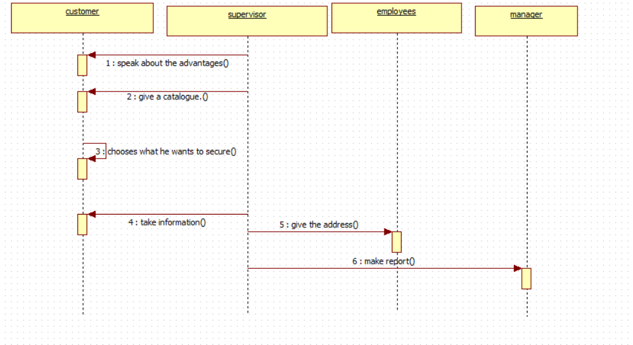

2.4

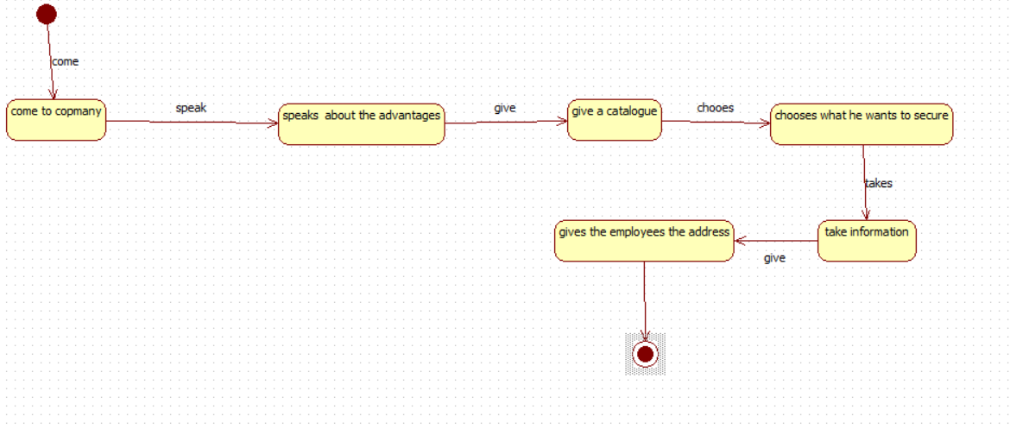

2.5

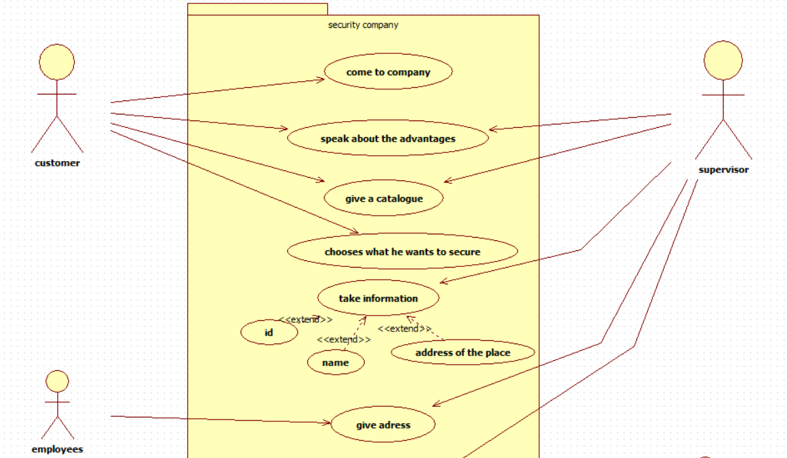

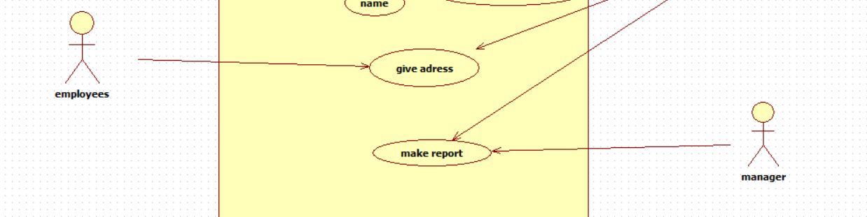

3.1

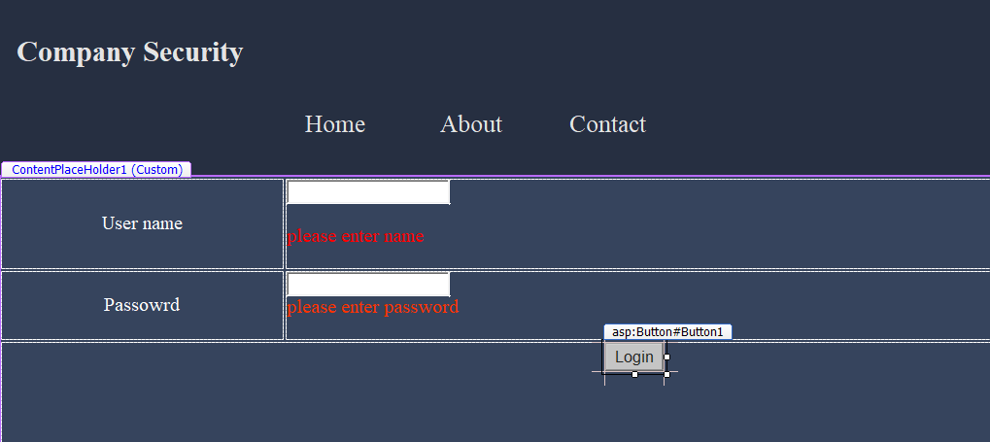

3.2
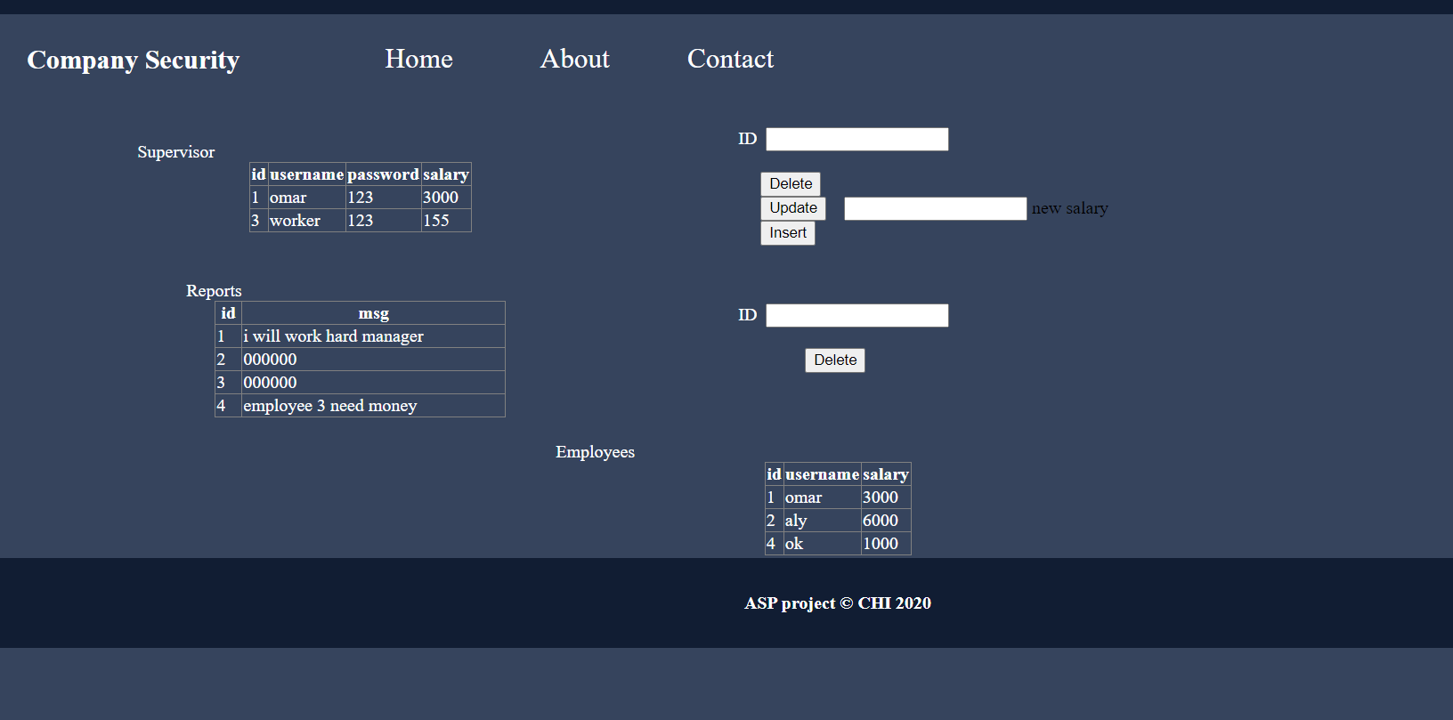
3.3
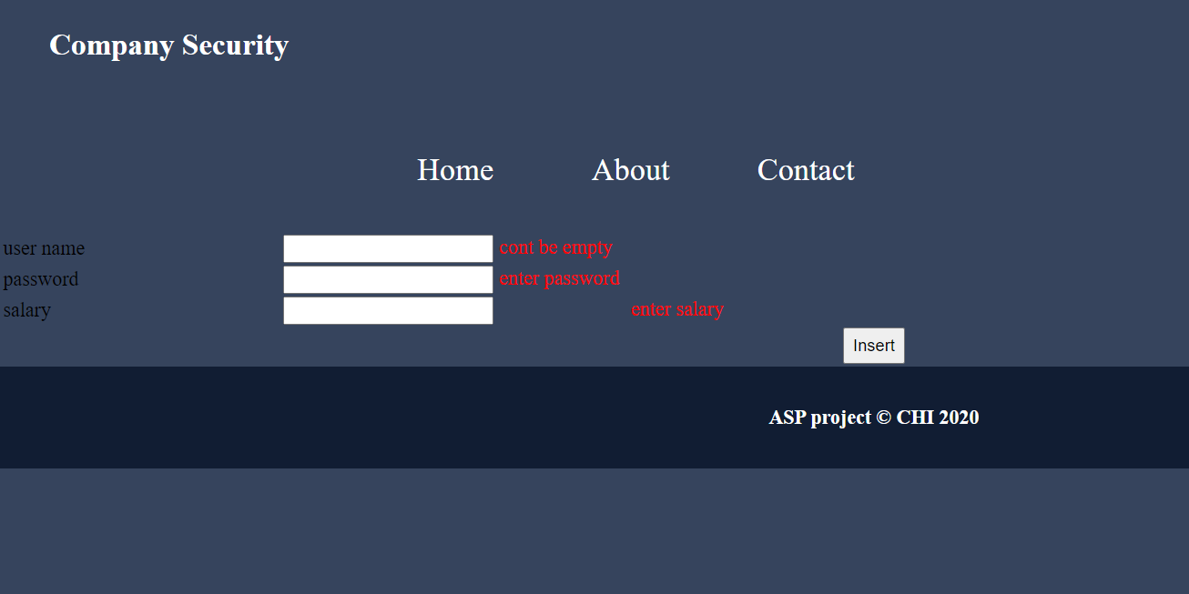

3.4

3.5
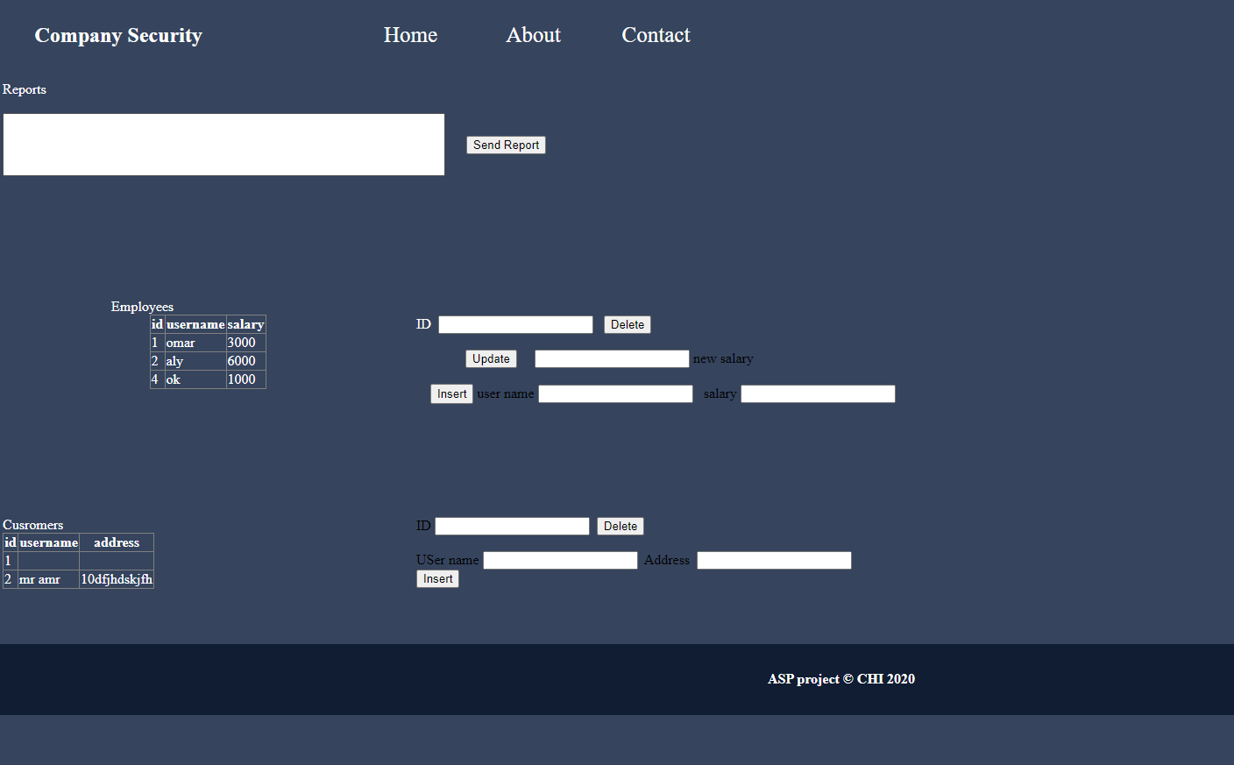 3.6

3.7

Chapter Five

Implementation
5.1 Introduction:
A customer comes to the company and the supervisor speaks to him about the advantages of the company in security and give him a catalogue.
Then the customer chooses what he wants to secure
After that supervisor takes information (the id, name and address of the place to sign the contract). The supervisor gives the employees the address to secure it. The supervisor makes an update to the employees' file and make inventory to the customers file and makes reports to the manager.
The manager gives salary.
5.2 Analysis Components:
-Scenario: a written outline of a film, novel, or stage work giving details of the plot and individual scenes.
-DFD: is a way of representing a flow of a data of a process or a system (usually an information system)
-FD: A diagram that indicates the functions of the principal parts of a total system and also shows the important relationships and interactions among these parts.
5.3 Design Components:
Class Diagram: is an illustration of the relationships and source code dependencies among classes in the Unified Modeling Language (UML)
Sequence Diagram : shows object interactions arranged in time sequence.
State Diagram: is a type of diagram used in computer science and related fields to describe the behavior of systems
Activity Diagram: graphical representations of workflows of stepwise activities and actions with support for choice
Use Case Diagram: is a graphic depiction of the interactions among the elements of a system

5.4 Database Components:
Sql Server: a relational database management system developed by Microsoft. As a database server
Sql Management Studio : a software application first launched with Microsoft SQL Server 2005 that is used for configuring, managing, and administering all components within Microsoft SQL Server
5.5 software Coding Components:
C# : a programming language developed by Microsoft that runs on the . NET Framework. C# is used to develop web apps, desktop apps, mobile apps, games and much more
Microsoft Visual Studio :an integrated development environment from Microsoft. It is used to develop computer programs, as well as websites, web apps, web services and mobile apps.
Asp.net : ASP.NET is an open-source,^{[2]} server-side web-application framework designed for web development to produce dynamic web pages. It was developed by Microsoft to allow programmers to build dynamic web sites, applications and services.
It was first released in January 2002 with version 1.0 of the .NET Framework and is the successor to Microsoft's Active Server Pages (ASP) technology. ASP.NET is built on the Common Language Runtime (CLR), allowing programmers to write ASP.NET code using any supported .NET language. The ASP.NET SOAP extension framework allows ASP.NET components to process SOAP messages.

Chapter Six
Conclusion and future work
5.1 Introduction.
5.2 Conclusion:
5.3 Future Work

Appendix
Source Code

using System;
using System.Collections.Generic;
using System.Linq;
using System.Web;
using System.Web.UI;
using System.Web.UI.WebControls;
using System.Data;
using System.Data.SqlClient;
namespace projectCompany
{
public partial class login : System.Web.UI.Page
{
protected void Page_Load(object sender, EventArgs e)
{
if(Request.QueryString["username"]!=null && Request.QueryString["password"] != null)
{
Label1.Text = Request.QueryString["username"];
Label2.Text = Request.QueryString["password"];

}

}

protected void Button1_Click(object sender, EventArgs e)
{
SqlConnection con = new SqlConnection();
con.ConnectionString = ("Data Source=DESKTOP-7LKJL60;Initial Catalog=company;Integrated Security=True");
con.Open();
SqlCommand cmd = new SqlCommand();
cmd.Connection = con;
cmd.CommandText = "select * from manager where username ='" + TextBox1.Text + "' and password ='" + TextBox2.Text + "'";
DataTable dt = new DataTable();
dt.Load(cmd.ExecuteReader());
con.Close();
if (dt.Rows.Count > 0)
{
Response.Redirect("Manager.aspx");
}
else
{

SqlConnection con2 = new SqlConnection();
con2.ConnectionString = ("Data Source=DESKTOP-7LKJL60;Initial Catalog=company;Integrated Security=True");
con2.Open();

SqlCommand cmd2 = new SqlCommand();
cmd2.Connection = con2;
cmd2.CommandText = "select * from supervisor where username ='" + TextBox1.Text + "' and password ='" + TextBox2.Text + "'";
DataTable dt2 = new DataTable();
dt2.Load(cmd2.ExecuteReader());
if (dt2.Rows.Count > 0)
{

Response.Redirect("Supervisor.aspx?username='"+TextBox1.Text+"'&password="+TextBox2.Text+" ");
}
else
{
Label3.Visible = true;
}

}

}
}
}
ـــــــــــــــــــــــــــــــــــــــــــــــــــــــــــــــــــــــــــــــــــــــــــــــــــــــــــــــــــــــــــــــــــــــــــــــــــــــــــــــــــــــــــــــــــــــــــــــــــــــ
using System;
using System.Collections.Generic;
using System.Linq;
using System.Web;
using System.Web.UI;
using System.Web.UI.WebControls;
using System.Data;
using System.Data.SqlClient;
namespace projectCompany
{
public partial class Manager : System.Web.UI.Page
{
protected void Page_Load(object sender, EventArgs e)
{

}

protected void Button1_Click(object sender, EventArgs e)
{
Response.Redirect("InsertSupervisor.aspx");
}

protected void Button2_Click(object sender, EventArgs e)
{
SqlConnection con = new SqlConnection();
con.ConnectionString = ("Data Source=DESKTOP-7LKJL60;Initial Catalog=company;Integrated Security=True");
con.Open();
SqlCommand cmd = new SqlCommand();
cmd.Connection = con;
cmd.CommandText = "update supervisor set salary = " + TextBox3.Text + " where id = " + TextBox1.Text + " ";
cmd.ExecuteNonQuery();
con.Close();

}

protected void TextBox3_TextChanged(object sender, EventArgs e)
{

}

protected void Button3_Click(object sender, EventArgs e)
{

SqlConnection con = new SqlConnection();
con.ConnectionString = ("Data Source=DESKTOP-7LKJL60;Initial Catalog=company;Integrated Security=True");
con.Open();
SqlCommand cmd = new SqlCommand();
cmd.Connection = con;
cmd.CommandText = "delete from supervisor where id = " + TextBox1.Text + " ";
cmd.ExecuteNonQuery();
con.Close();
Response.Redirect("Manager.aspx");
}

protected void Button6_Click(object sender, EventArgs e)
{
SqlConnection con = new SqlConnection();
con.ConnectionString = ("Data Source=DESKTOP-7LKJL60;Initial Catalog=company;Integrated Security=True");
con.Open();
SqlCommand cmd = new SqlCommand();
cmd.Connection = con;
cmd.CommandText = "delete from reports where id = " + TextBox2.Text + " ";
cmd.ExecuteNonQuery();
con.Close();
Response.Redirect("Manager.aspx");
}
}
}
ــــــــــــــــــــــــــــــــــــــــــــــــــــــــــــــــــــــــــــــــــــــــــــــــــــــــــــــــــــــــــــــــ
using System;
using System.Collections.Generic;
using System.Linq;
using System.Web;
using System.Web.UI;
using System.Web.UI.WebControls;
using System.Data;
using System.Data.SqlClient;
namespace projectCompany
{
public partial class InsertSupervisor : System.Web.UI.Page
{
protected void Page_Load(object sender, EventArgs e)
{

}

protected void Button1_Click(object sender, EventArgs e)
{
SqlConnection con = new SqlConnection();
con.ConnectionString = ("Data Source=DESKTOP-7LKJL60;Initial Catalog=company;Integrated Security=True");
con.Open();
SqlCommand cmd = new SqlCommand();
cmd.Connection = con;
cmd.CommandText = "insert into supervisor (username,password,salary) values ('" + TextBox1.Text + "' ,'" + TextBox2.Text + "' ," + TextBox3.Text + " ) ";
cmd.ExecuteNonQuery();
con.Close();
Response.Redirect("Manager.aspx");
}
}
}

DATABASE CODE
create database company
create table manager(
id int primary key,
username varchar(30),
password varchar(30)
);
create table supervisor(
id int primary key identity,
username varchar(30) unique,
password varchar(30),
salary float
);
create table employees(
id int primary key identity,
username varchar(30) unique,
salary float
);
create table customers(
id int primary key identity,
username varchar(30) unique,
address varchar(30)
);
create table reports(
id int primary key identity,
msg varchar(500)
);

insert into manager values(1,'mado','123');
insert into supervisor (username,password,salary) values('omar','123',3000);
insert into reports (msg) values(' i will work hard manager');
insert into employees (username,salary) values('omar',3000);
insert into employees (username,salary) values('aly',2000);

References
Books references:
C#
Sql Server
Sites references:
Stackoverflow.com
wikibedia.com
w3school.com

Table of Content
1.Project name .................................................................. page 1
2.Absract..............................................................................page 2
3.Acknowlogment................................................................page 3
4.list of figures ....................................................................page 4
5.Figures ..............................................................................page 5
6.Implementation .................................................................page 15
7.Conclusion and Future work ...........................................page 16
8.Appendix ...........................................................................page 18
9.References ........................................................................page 25
10.table of content ...............................................................page 26
11.Abstract(Arabic)...............................................................page 27
12.Project name (Arabic).....................................................page
28

ملخص

تصميم وبناء
نظام إدارة شركة الأمن
يأتي العميل إلى الشركة ويتحدث المشرف معه عن مزايا الشركة في مجال الأمن ويقدم له كتالوجًا.
ثم يختار العميل ما يريد تأمينه
بعد ذلك يأخذ المشرف المعلومات (المعرف والاسم وعنوان المكان للتوقيع على العقد). يعطي المشرف الموظفين العنوان لتأمينه. يقوم المشرف بعمل تحديث لملف الموظفين ويقوم بعمل جرد لملف العملاء ويقدم تقارير إلى المدير.
المدير يعطي الراتب.



مشروع(1)

نظام إدارة شركة الأمن
مشرف المشروع : م.هدير
اسماء افراد المشروع:
- عمر محمد مختار
- 2017030018

القاهره 2020

